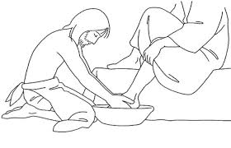Wiest Memorial UM Church
Holy Thursday Communion
April 14, 2022
Greeting and Welcome
Praise and Worship
Come to the Table
*OPENING HYMN God of Love and God of Power #578
(Verses 1, 3 & 4)
Opening Prayer
The Scripture Lesson John 13: 1-17, 31b-35
Special Music The Old Rugged Cross Chub Weidler
The Message Cleaned Through… Pastor Lyle
Hymn of Preparation Just As I Am Without One Plea # 357
(Verses 1, 3 & 5)
Celebration of Holy Communion
Please follow the service of Word and Table III on page 15 of the hymnal.
We will follow a tradition tonight which has been passed down to us for many years, when you are ready, come to the table, to share in the Last Supper Meal. Let us do this in a time of silent prayer. After you share in Communion, and your time of prayer, take this holy time to your memory. You are dismissed. Please leave the worship center in silence. Please do not talk until you are back in the fellowship hall. Thank you and please invite neighbors, relatives, and friends to worship with you on Easter Sunday morning.

