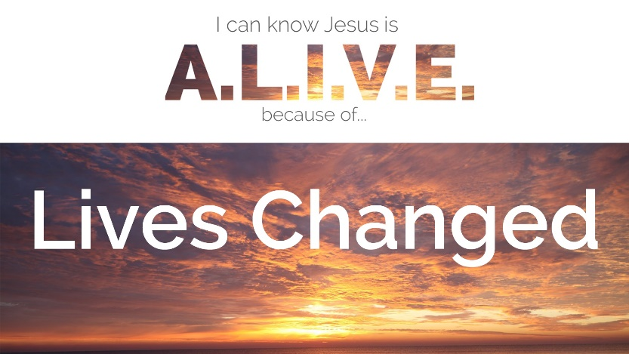

Second Sunday after Christmas, January 7, 2023

Greeting
Birthdays and Anniversaries
Call to Worship:
Pastor: Bless the Lord, O my soul
People: Let all that is within me, bless his holy name.
Pastor: Bless the Lord all the angels that do his bidding and heed his word.
People: Bless the Lord all of his work, bless the Lord O my soul.
Worship Music Waymaker
OPENING PRAYER
Lord, open us up to the Love of Jesus Christ, so that we can feel the hope of our ancestors and the energy of our children. Continue to weave us together as a community, so we no longer see our aches and pains, but our collective strength. Help us to spread healing wherever we go, planting the seeds of love, and giving the words of hope. In Jesus’ Name we pray. AMEN.
*OPENING HYMN Great Is Thy Faithfulness #140
THE OLD TESTAMENT LESON Psalm 103: 1-5 NLT
PRAYERS OF THE PEOPLE
OFFERTORY INVITATION:
We are called in virtue of our baptism to a life of service. We are equipped through the gifts and grace of the Holy Spirit. Let us live into our baptismal calling, sharing from what we have received according to the measure of Christ’s gift.
OFFERTORY
*DOXOLOGY #95
*OFFERTORY PRAYER
Holy God, we trust in the provisions of your love and the abundance of your grace. May the gifts we offer bring glory to you in the ways they bear your love into the world. We ask this in Jesus’ name, Amen.

THE GOSPEL LESSON Mark 2: 1-22 NIV
HYMN OF PREPARATION Jesus’ Hands Were Kind Hands #273
SERMON Lives Changed Pastor Lyle
The Great Thanksgiving
Invitation to Communion:
We come to this table not because we must but because we may, not because we are strong, but because we are weak. We come, not because any goodness of our own gives us a right to come, but because we need mercy and help. We come, because we love the Lord and would like to love him more. We come, because he loved us and gave himself for us.

Unison Prayer of Confession:
Gracious and loving God, open our hearts so that we are able to admit to you the fullness of our lives – that which is beautiful and good, and that which is hurtful and hateful. We confess that we do not follow Jesus in all that we do.
We love with condition. We judge and condemn. We cast the first stone, and keep the logs in our own eyes. We do not turn to You as the source of our healing. Forgive us, we pray. Forgive our sin, and empower us to be imitators of Christ in love and service. Amen.
Time of Silent Personal Confession
Assurance of Forgiveness
Friends in Christ, know this: the mercy of God is from everlasting to everlasting, and I remind you of this surpassing grace – in Jesus Christ, we are forgiven.
Alleluia! Amen.
Please follow the liturgy at page 15 in the hymnal.
THE GREAT THANKSGIVING
THE BLESSING OF THE BREAD AND CUP
THE LORD’S PRAYER
Our Father, who art in heaven, hallowed be thy name;
Thy kingdom come, thy will be done, on earth as it is in heaven.
Give us this day our daily bread; and forgive us our sins, as we forgive those who sin against us; and lead us not into temptation but deliver us from the evil one. For thine is the kingdom and the power and the glory, forever. Amen

THE CELEBRATION OF COMMUNION
GIVING THE BREAD
As the bread is passed by the ushers, we will sing together Come, Sinners to the Gospel Feast #616 (Verses 1 & 2). Please hold bread until instruction by the pastor. We will all share it together.
GIVING THE CUP
As the cup is passed by the ushers, we will sing together Come, Sinners, to the Gospel Feast #616 (Verses 3, 4 & 5). Please hold the cup until instruction by the pastor. We will all share it together.
POST COMMUNION PRAYER

*CLOSING HYMN Have Thine Own Way, Lord #382
BENEDICTION
Hear the good news: God is doing a new thing! Refreshed and renewed
by the waters that unite us to God and to each other, let us go into the
world, empowered by the Holy Spirit, following the way of Jesus Christ.
May the grace of our Lord, Jesus Christ, the love of our parent God, and
the fellowship of the Holy Spirit be with us, today and always. Amen.
ANNOUNCEMENTS
Our Prayer List:
Amber – breast cancer Pat Horst – oblation Friday
Margaret Bollinger -pancreatic cancer Kellen – reaction to lymphoma treatment
Ron Dentzer – cancer Family of Bill Lesher
Erla Dinger – Covid Faye Miller - immunotherapy for cancer
Family of Lee Elwell People in Israel and Gaza and Ukraine
Lynne Elwell- surgery February 1st Keith Pettus – tonsillectomy January 16th
Tracy Finefrock – recovering from Connie Rupp – York Hospital
knee surgery Linda Slafkovski – metastatic cancer
Dennis Foltz – recovering Sharon - brain cancer
Donna – cancer treatable Alex Wenger – treatments for leukemia
Justin Grube – kidney disease Isabell Yan – granddaughter of Pat Jones
Rich & Cindy Haines – life issues 6 lbs 10oz Dec 12th
Don Smith – stage 4 cancer
SUNDAY MORNING OFFERING
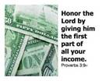
OFFERING AMT NEEDED EACH WEEK $1,400
OFFERING December 31st $ 923
AMT OF OFFERING NEEDED TO $74,200
AMT RECEIVED TO DATE $72,654
BUDGET YTD -$1069 Attendance – 39 Folks
What’s happening at Wiest:
Adult Sunday School – 1015 Sundays
Bible Study – resuming January 16^{th.}
Girl Scouts – 2nd Thursday of each month
Game Day – Thursday January 11th and January 25th 130-330 PM
Blessings of Hope – Saturday January 27th 1030-1100
Audio of the Sunday message is posted on our church website (www.wiestchurch.org). Video on Wiest Church Facebook page

Lectionary Readings for next week: Sunday – Mark 2:18-22
Monday – Mark 2:23-28 Thursday – Mark 3:13-19
Tuesday – Mark 3:1-6 Friday – Mark 3:20-27
Wednesday –Mark 3:7-12 Saturday – Mark 3:28-35

Sermon Summary
Lives Changed
January 6th is the day of Epiphany. It is a celebration of God manifesting as the baby Jesus and revealing Himself to the world. The lesson from Mark is an epiphany in that it reveals to us who Jesus is and how He reveals God to us through his words and actions. Jesus had come home to Capernaum and was teaching from his home. So many people were present that the doorway was blocked. Four friends wanted to get their paralyzed friend to Jesus, so the dug a hole in the roof and lowered him on a mat. Jesus saw their faith and forgave the man of his sins and then healed him. The teachers present thought that Jesus forgiving sins was blasphemy. Jesus’ healing of the paralytic was proof that he was connected to God.
Then as he was walking and teaching along the lakeshore, he called Levi, the tax collector to follow him. Levi did so and later hosted Jesus, tax collectors and sinners at his house. Jesus had come to save more than the teachers expected and they complained to Him. Jesus told them that he had come to save the sick, not those who were well.
When questioned about why his disciples did not fast, he said that they could fast after He was gone. Fasting was to be done for the right reasons. He used examples of new cloth sown onto old cloth and putting new wine in old wineskins as examples of how things were different because He was present. His presence among those who believed in Him should lead to new behaviors.

Sermon Quiz
- Epiphany celebrates God’s ________ himself to the world as the baby ____.
- Mark teaches us about who Jesus is; the _________ of the ____ who is revealed in him; and the His works of mercy and restoration. ministry.
- Jesus was back home; he taught at home and the crowds blocked the _____.
- _____ friends lowered a paralytic through the _____ on a mat.
- Jesus saw their _____ , forgave the man’s ____ and then healed him.
- Jesus choose Levi as a ________ as he walked along the lakeshore.
- He told the teachers that he came to save _______, not those who were well.
- Jesus was called to save more than the teachers ________.
- Jesus preached that _______ was to be done for the right ________.
- Putting new wine in new wineskins symbolized new ________ as a result of the ______.

Last Week’s Quiz
- Mark 1 tells us of the fulfillment of prophesies from the prophets.
- Jesus, God incarnate, had Come From Away to be with us.
- Mark introduced readers to who Jesus was and how he fit within Jewish prophecy and history.
- John prepares the way for Jesus instead of God.
- John’s baptisms were not the same baptism as Christian baptism.
- The heavenly voice also confirms Jesus’ identity.
- The world has fundamentally changed with the arrival of Jesus.
- For John and Jesus, the “good news” was about the coming of the kingdom of God.
- Belief in this gospel initially implied Torah faithfulness and later included trust in Jesus’ teachings as God’s anointed messenger.
- The initial steps of Jesus’ public ministry introduce the first disciples who would spread the good news of the coming of the kingdom of God.

