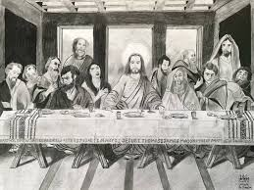
Wiest Memorial UM Church
Holy Thursday Communion
March 28, 2024
Greeting and Welcome
Praise and Worship Come to the Table
Opening Prayer
*OPENING HYMN Go to Dark Gethsemane #290
Reading from the Psalms Psalm 116: 12-19
Hymn We Gather Together #131
The Gospel Lesson Mark 14: 22-42
SPECIAL MUSIC In the Upper Room Teresa Martin and Vanessa Hable
The Message All Are Freed By the Blood… Pastor Lyle
Hymn of Preparation For the Bread Which You Have Broken # 614

Celebration of Holy Communion
Please follow the service of Word and Table III on page 15 of the hymnal.
We will follow a tradition tonight which has been passed down to us through the years. When you are ready, come to the table to share in the Last Supper Meal. Let us do this in a time of silent prayer. After you share in Communion, and your time of prayer, take this holy time to your memory. You are dismissed. Please leave the worship center in silence. Please do not talk until you are back in the fellowship hall. Thank you and please invite neighbors, relatives, and friends to worship with you on Easter Sunday morning.

We invite you to come to the Community Egg Hunt at the Schoeneck Park on Saturday, March 30th at 2PM. The children are placed in age groups. Both real and plastic eggs are collected by the children. There will be Easter candy for all.

Our Easter Sunday worship on March 31st begins at 9 AM. We invite you to attend to celebrate Christ’s Resurrection with us.
Mt Zion Akron will observe Good Friday with a service on Friday, March 25th at 1200 . The church is located at 105 N 11th Street, Akron, PA.

