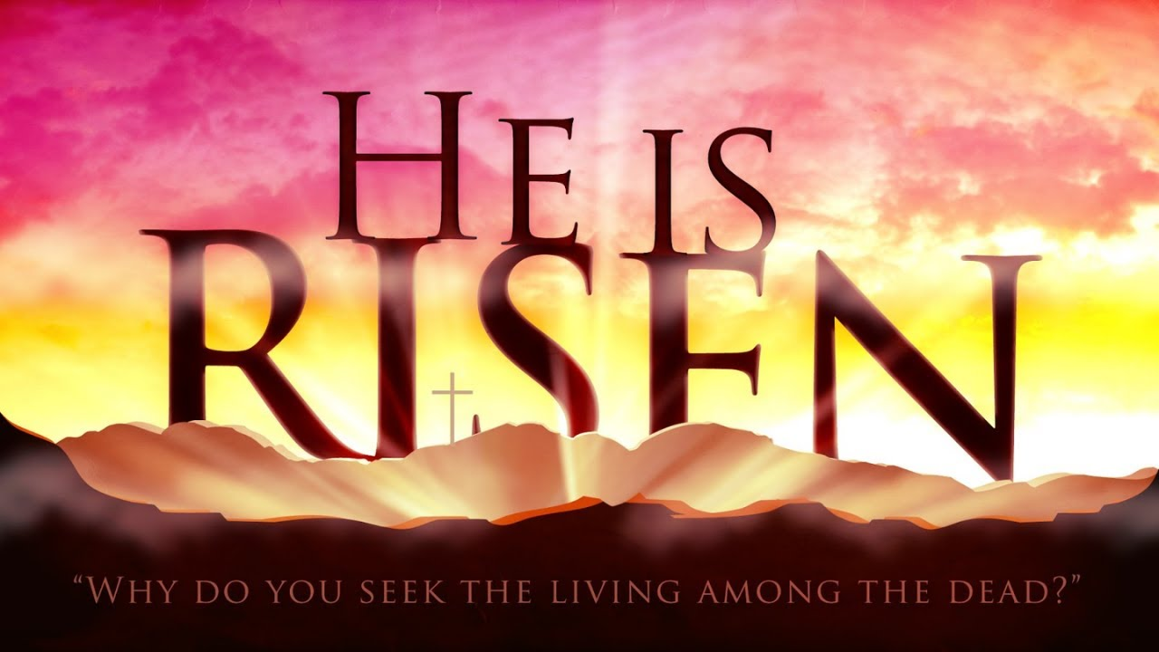

Easter Sunday, March 31, 2024

Greeting
Call to Worship:
Pastor: The stone has been rolled away!
People: Christ is Risen!
Pastor: The tomb is found empty!
People: Christ is Risen!
Pastor: The angel has told us, “He is not here.”
People: Christ is Risen!
Pastor: Death is vanquished!
People: Christ is Risen!
Pastor: Hope lives!
People: Christ is Risen!
Pastor: Love wins!
People: Christ is Risen!
Pastor: Christ is Risen!
People: Christ is Risen Indeed!

Worship Music Because He Lives
OPENING PRAYER
Creator God, You make all things new. On this Easter morn we remember that Your steadfast love endures forever, through life and death. There is nothing that can hold us back from Your love. On this morning, may our hearts be broken open to hear the message of Your love for us, through Jesus Christ, the one who gave himself up on the cross so that death would not have a hold on us. The love of Jesus leads us to eternal life, a new life that begins now, and today, we celebrate, give thanks, and praise Your name. AMEN.
*OPENING HYMN Christ the Lord Is Risen Today (Verses 1-4) #302
THE OLD TESTAMENT LESSON Psalm 118: 21-27 NIV
PRAYERS OF THE PEOPLE
SPECIAL MUSIC In Christ Alone Tracy Finefrock and Mark Potts
OFFERTORY INVITATION:
In this economic climate, fear is the greatest obstacle to generosity: fear that there isn’t enough to go around; that if we give away what we have, we won’t be able to take care of our own needs. Fear is like a big stone standing between us and the experience of the resurrection miracle. So “who will roll away the stone?” We will, through the gifts we now give.
OFFERTORY
*DOXOLOGY #95
*OFFERTORY PRAYER
God of new life, we offer these gifts, acknowledging our fear but stretching beyond it to generosity. May these gifts help to roll away the stones that stand in the way of those in need; in our community and the world. We thank you for your empowering love. Amen.
THE GOSPEL LESSON Mark 16: 1-8 NIV
HYMN OF PREPARATION He Is Lord #177
SERMON Unfinished Business Pastor Lyle
The Great Thanksgiving
Invitation to Communion:
The table of the United Methodist Church is an open table. All who repent of their sin and confess that Jesus Christ is Lord are welcome. We come to this table not because we must but because we may, not because we are strong, but because we are weak. We come, not because any goodness of our own gives us a right to come,
but because we need mercy and help. We come, because we love the Lord and would like to love him more. We come, because he loved us and gave himself for us.
Unison Prayer of Confession:
Gracious God, you have walked patiently with us throughout our Lenten journey. You have celebrated our successes and our growing understanding of your love; and you have mourned our failures and rejections of your healing mercies. This day, as we have gathered to celebrate the joy of Easter, let us remember that we are to become “Easter People”, people of the Resurrection; people who know that what was thought to be impossible has been conquered. Forgive our stubbornness and fears. Fill us with your healing love and help us to become the disciples that you need to serve in this world. For we ask this in the name of our Risen Lord, Jesus Christ. AMEN.
Time of Silent Personal Confession
Assurance of Forgiveness
Darkness is gone! Light floods into our souls! Christ is Risen! His love and mercy are poured out for you. Rejoice! You have been saved through the gift of Jesus Christ. AMEN.
Please follow the liturgy at page 15 in the hymnal.
THE GREAT THANKSGIVING
THE BLESSING OF THE BREAD AND CUP
THE LORD’S PRAYER
Our Father, who art in heaven, hallowed be thy name;
Thy kingdom come, thy will be done, on earth as it is in heaven.
Give us this day our daily bread; and forgive us our sins, as we forgive those who sin against us; and lead us not into temptation but deliver us from the evil one. For thine is the kingdom and the power and the glory, forever. Amen

THE CELEBRATION OF COMMUNION
GIVING THE BREAD
As the bread is passed by the ushers, we will sing together Come, Sinners to the Gospel Feast #616 (Verses 1 & 2). Please hold bread until instruction by the pastor. We will all share it together.
GIVING THE CUP
As the cup is passed by the ushers, we will sing together Come, Sinners, to the Gospel Feast #616 (Verses 3, 4 & 5). Please hold the cup until instruction by the pastor. We will all share it together.
POST COMMUNION PRAYER

*CLOSING HYMN He Lives #310
BENEDICTION
May the God of all goodness and mercy follow you on this Lenten journey and may the barren parts of your life be made fruitful through the grace of Jesus Christ and the power of the Holy Spirit. Amen.
ANNOUNCEMENTS
Our Prayer List:
Amber – breast cancer Faye Miller - immunotherapy
Jim Adams – recovering at home Nash – leukemia (home)
Margaret Bollinger – stroke, aneurysm Art Pannebecker – heart issues
Phyllis Busey – Ephrata Manor People in Israel, Gaza and Ukraine
Brad – nephew of Pastor Glenda Mr. Quinn – rehab at Neffsville
Carol Collemacine- sprained ankle Michael Royer – recovering from fall
Michelle Daniels - chemotherapy Connie Rupp – hospice care at Fairmont
Family of Harry DeKolf Dr. Bill Schlorff – cancer doing well
Donna – cancer treatable Sharon - brain cancer
Ed Finefrock – appointments Linda Slafkovski – metastatic cancer
Janet Fisher – recovering from fall Dawn Smith – stage 4 cancer
Sherry Gregory – stroke Greg and Sue Steininger – difficult time
Cindy Haines – at home not doing well Roy Weik – Health Center Cornwall
Mary Jenks – healing Alex Wenger- leukemia
Gloria Lintner- healing

SUNDAY MORNING OFFERING
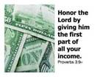
OFFERING AMT NEEDED EACH WEEK $1,400
OFFERING March 24th $5,892
AMT OF OFFERING NEEDED TO $17,000
AMT RECEIVED TO DATE $30,708
BUDGET YTD +$13708 Attendance – 36 Folks
What’s happening at Wiest:
The Chosen – video series – 1030 Sunday after church resumes April 28th
Choir Practice – Thursdays 1200 PM
Girl Scouts – 2nd Thursday of each month
Game Day – Thursday April 11th and April 25th 130-330 PM
Blessings of Hope – Saturday April 27th 1030-1100
Memorial Service for Pastor Harry DeKolf – Saturday May 4th 1100 AM
Pastor Lyle and Cheryl will be on vacation out of the country from April 1st through April 21st. Pastor Glenda Machia from Mt Zion-in Akron will provide pastoral coverage during this time. Her telephone number is 717-468-4920.

Audio of the Sunday message is posted on our church website (www.wiestchurch.org). Video on Wiest Church Facebook page

Address for Mrs. Lana DeKolf: 39 Gary Court
Spotswood, NJ 08884

Lectionary Readings for next week: Sunday – Mark 16: 1-8
Monday – John 20: 1-10 Thursday – Luke 24: 28-35
Tuesday – John 20: 11-18 Friday – Luke 24: 36-49
Wednesday – Luke 24: 13-27 Saturday – Matthew 28: 16-20

Sermon Summary
Unfinished Business
Easter is finally here. Jesus is alive! He has risen from the tomb. We Christians believe impossible things. Paul says that is what makes us different. We fix our eyes on things that are unseen. Mark ends his Gospel with and unbelievable story of God’s work in the world.
Women take center stage, as they go to the tomb to anoint Jesus’ body. We don’t know what they talked about on the way to the tomb. Maybe they wondered who they could find to roll the stone away from the entrance to the tomb. Jesus’ unspeakable death leaves them few topics to engage but the weather and practical considerations of his burial. They probably were also afraid. When they arrived and the tomb, they found that the stone had been rolled away. When they entered the tomb, they met an angelic figure dressed in white. He told them not to be afraid. How could they be anything else? Jesus was gone! He told them to go and tell Peter and the disciples that Jesus had gone on ahead of them to Galilee. He would see them there.
The two Mary’s were afraid and fled and said nothing to anyone. The rest of the story is left to us. The end of Mark’s Gospel presents the reader with unfinished business. After their command to go and tell, the women represent the unfinished business of the Gospel. Instead of immediately going and telling the disciples, they flee in terror. The rest of the story is left to us. The end of Mark’s Gospel presents the reader with unfinished business. After their command to go and tell, the women represent the unfinished business of the Gospel. Instead of immediately going and telling the disciples, they flee in terror and are silent.
Imagine what it would have felt like to receive this unbelievable news. How does one respond when the worst and best news of one’s life come so closely intertwined? It isn’t hard to imagine the jumble of emotions. We have the interpretive audacity of 2,000 years of knowing how the story goes.
The point to remember is it was not what the women or the disciples did; it was what God did.
The women must have found their voices. Have we found ours? They were in terror at the death of their Lord, and fearful of the God who raised Jesus from the dead.
They were left behind to tell the story. We have been left behind as well to continue to tell the story too. Jesus has gone on ahead of us to guide us. This is the hope of the resurrection.
Let us pray:
Holy Lord Jesus, on this day we rejoice in your glory and stand in awe of how you have transformed this world with your dying and your rising. Receive our joyful praise. Alleluia! Amen.

Sermon Quiz
- We Christians believe _____________ things.
- Paul says we are different because we fix our eyes on things _______.
- Easter shows us the _____________ richness and joy of God’s work in the world.
- The women went to the tomb and found the _____ rolled away.
- They met an _______ figure in white when they entered the tomb.
- He told them not to be _______ and to tell Peter and the disciples that Jesus had gone ahead to ________ and they should meet him there.
- We are left with __________ business.
- The point to remember is it was ___ what the women or the disciples did; it was what God ____.
- To believe in the ___________ is what the _________ of God allows us to do.
- Jesus goes ahead of us to ______ us; this is the hope of the __________.

Last Week’s Quiz
- Jesus and his followers come from the west to observe Passover in Jerusalem.
- Passover recalls God’s freeing of the people from enslavement in Egypt.
- Jesus will offer a different kind of deliverance than what the people hoped for.
- The people shouted Hosanna and quoted from Psalm 118.
- The people laid clothes and leafy branches on the road.
- Hosanna means save us, save us now.
- The people thought Jesus would be the warrior king who would save them.
- Jesus confronted authority, but in a non-violent manner.
- He went into the Temple and looked around.
- Jesus left the city and returned to Bethany.

